

SMALL EMBEDDED SYSTEM Assignment

Small Embedded System

Electronic Skateboard

2018-2019

Kai Chen

2019-5-9

UNIVERSITY OF BIRMINGHAM

Student ID: 1948361

Content

**1.** **Description of product** 2

**2.** **Hardware design** 2

**The component of the electric skateboard:** 2

**2.1** **Sensor** 2

**2.2** **Processor** 3

**2.2.1** **Amplifier** 3

**2.2.2** **Adafruit Feather HUZZAH ESP8266** 4

**2.3** **Motor** 4

**2.4** **Battery** 5

**2.5** **Dual Motor Mechanical Kit** 6

**3.** **Software design** 7

**3.1** **Beginning** 7

**3.2** **Auto Balance and Foot control system** 8

**3.3** **Mobile Phone Control System** 9

**3.4** **Android Application** 9

**4.** **Evaluation** 10

**4.1** **The evaluation for the load cell sensor** 10

**4.2** **Processor Evaluation** 11

**4.3** **Battery Evaluation** 12

**5.** **Conclusions** 12

**Reference** 13

1. **Description of product**

In some areas of our society where vehicles are banned, people often need to walk to their destination, but sometimes the distance between the places is still very far, so in this mission, our team developed a product - electric skateboard. Compared with this product, other products of the same type, such as bicycles, are easily stolen and inconvenient to carry in schools or residential areas. The electric skateboard is easy to carry for students and can be placed within their sights when not being used. In addition, the electric skateboard we designed is different from the ordinary skateboard on the market. Ordinary skateboards use the remote control to control the movement of the skateboard, which means that if the battery in the remote control is exhausted, the user can no longer control the skateboard, which is a very intuitive and serious safety issue. For this purpose, we developed an app to control the skateboard, which is more convenient. In addition, our team worked together to design a balancing system that allows first-time users to easily control the skateboard while avoiding danger.

1. **Hardware design**

**The component of the electric skateboard:**

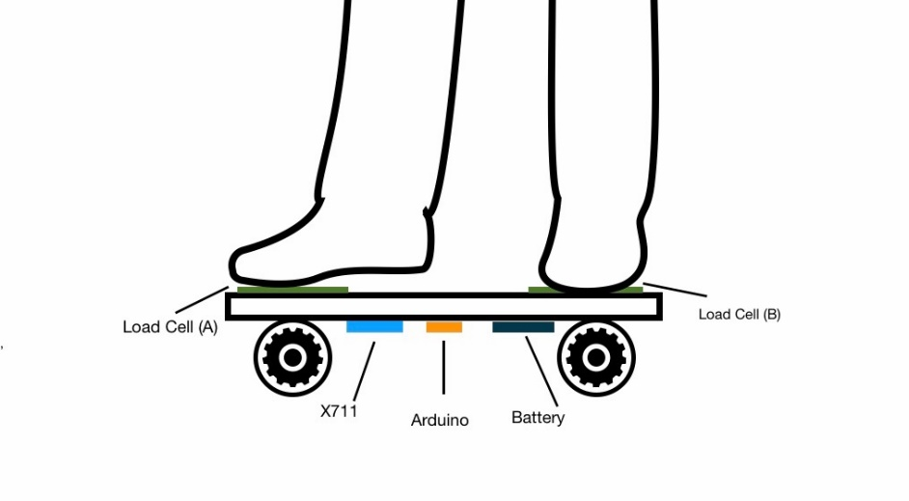

Figure 1 Diagram of the system architecture (from Miaoyu Niu)

* 1. **Sensor**

Load cells are specially shaped metal parts that have strain gauges glue to them. The strain gauges are resistors that change their resistance when they are bent. When the metal part bends, the resistance of the load cell changes. The module uses 24 high-precision A/D converter chip HX711, is designed for high-precision electronic scale and design, with two analog input channels, the internal programmable gain amplifier integrated multiplier 128. The input circuit can be configured to provide a bridge voltage electrical bridge (such as pressure, weight) sensor model is an ideal high-precision, low-cost sampling front-end module. Besides, the cost of load cell is $7 *2= $14.

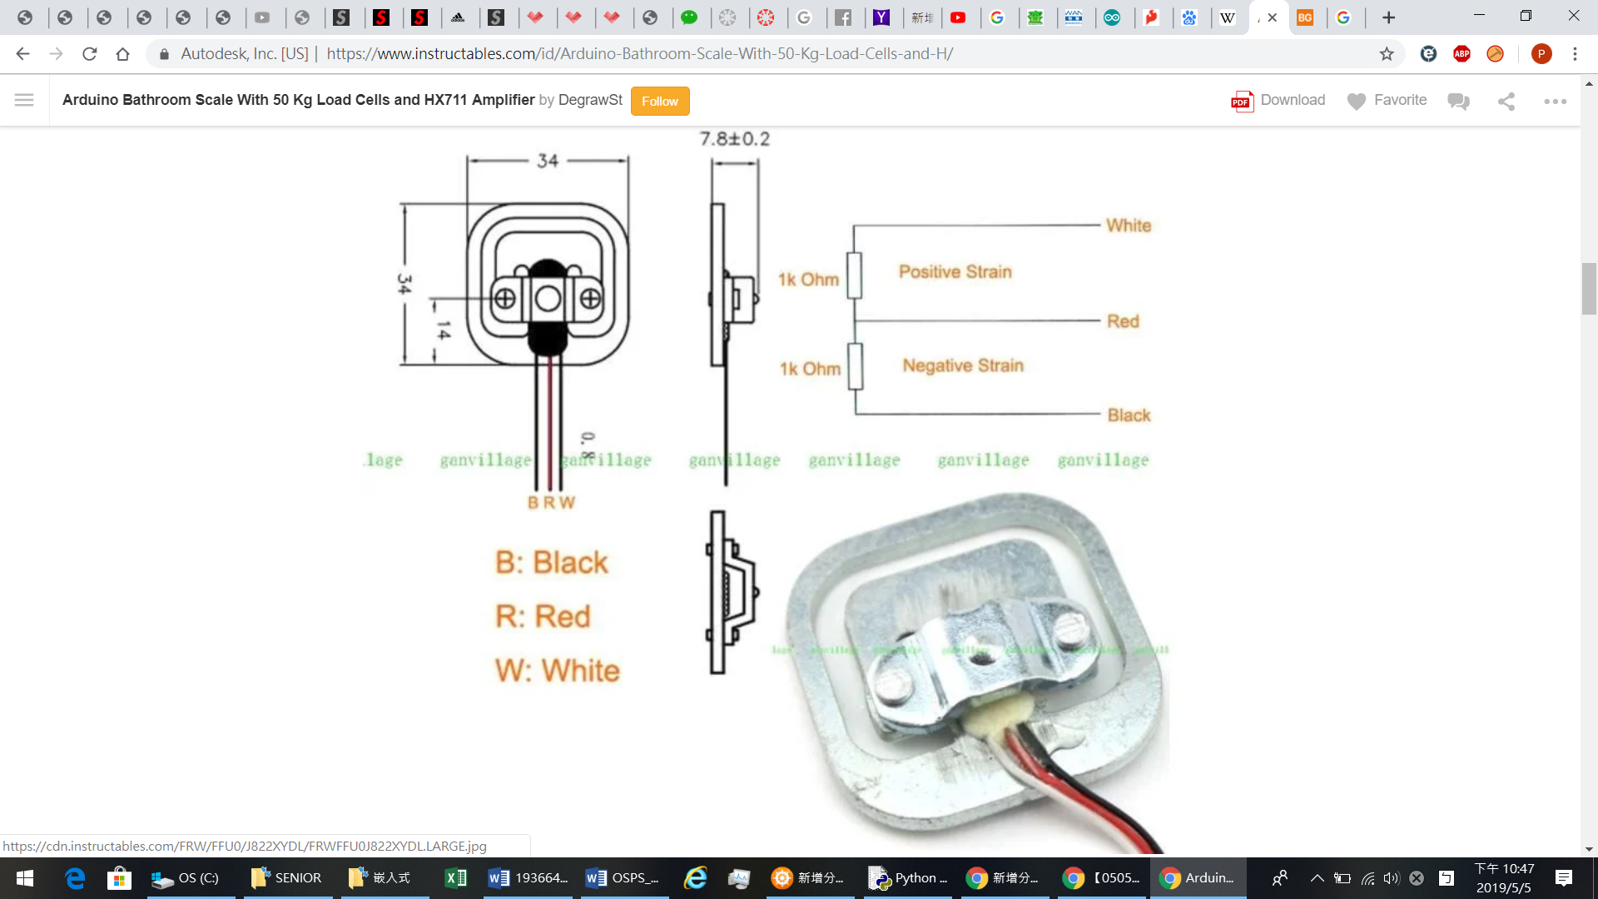

Figure 2 Diagram of the load cell construction (from Po-Chang Chiu)

* 1. **Processor**
     1. **Amplifier**

This microchip is used to amplifying the signals from load cells and reporting them to another microcontroller which is Arduino board in this case. The load cells plug into this board, and this board tells the Arduino what the load cells measuring.

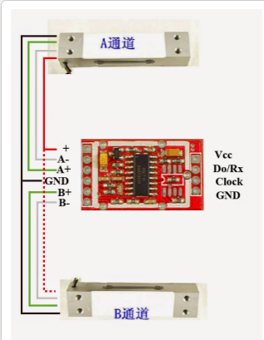

Figure 3 Diagram of Signals Amplifier

The specifications of load cell are as follows:

* Refresh Frequency: 10/80 Hz
* Operation supply voltage range: 4.8 ~ 5.5V
* Operation supply Current: 1.6mA
* Operation temperature range: -20 ~ +85℃
* Cost: $9.95
* Size: Approx. 36mm x 21mm x 4mm / 1.42" x 0.83" x 0.16"
  + 1. **Adafruit Feather HUZZAH ESP8266**

This is the Adafruit Feather HUZZAH ESP8266 - our take on an 'all-in-one' ESP8266 Wi-Fi development board with built in USB and battery charging. It is an ESP8266 Wi-Fi module with all the extras we need, which heart is an ESP8266 Wi-Fi microcontroller clocked at 80 MHz and at 3.3V logic. This microcontroller contains a Tensilica chip core as well as a full Wi-Fi stack. We can program the microcontroller using the Arduino IDE for an easy-to-run Internet of Things core. We wired up a USB-Serial chip that can upload code at a blistering 921600 baud for fast development time. It also has auto-reset so no noodling with pins and reset button pressings.

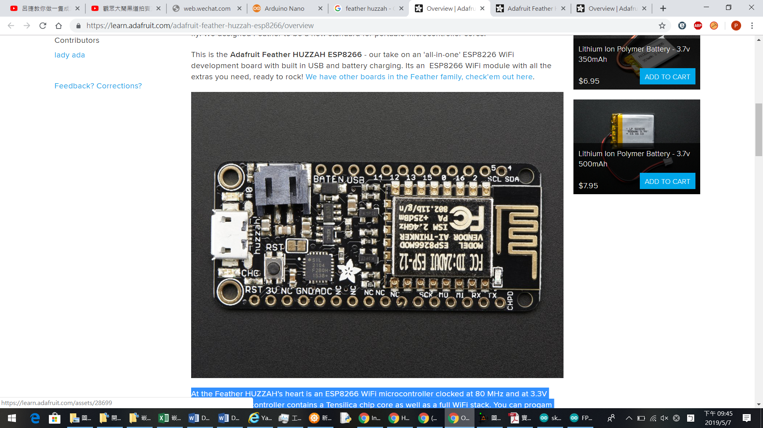

Figure 4 Arduino Feather HUZZAH ESP8266 (from lab1)

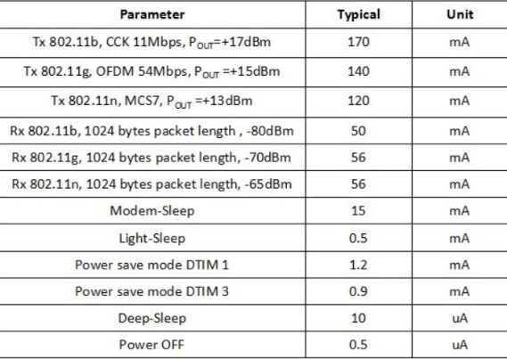

*Figure 5 power consumption of ESP8266*

* Measures 2.0" x 0.9" x 0.28" (51mm x 23mm x 8mm) without headers soldered in
* Light as a (large?) feather - 6 grams
* ESP8266 @ 80MHz or 160 MHz with 3.3V logic/power
* 4MB of FLASH (32 M-Bit)
* 3.3V regulator with 500mA peak current output
* 1 x analog inputs 1.0V max
* Power/enable pin
* 4 mounting holes
* Reset button
  1. **Motor**

We choose this motor - ELECTRIC SKATEBOARD MOTOR 6374 190KV because it is a sensor motor that can be run using the sensors or without using the sensors. We can just tuck sensor wires into enclosure and keep them disconnected. This motor mainly fit for electric skateboards and electric bikes, as well as underwater propellers and robots, can be used with large aircraft models

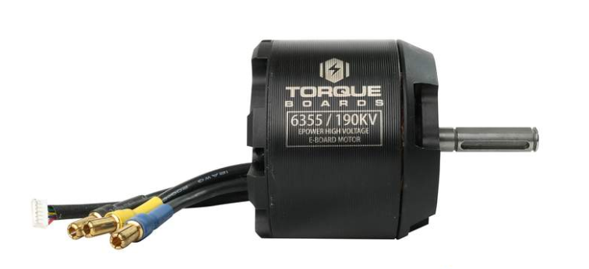

Figure 6 Diagram of Electric skateboard motor

The motor specifications are as follows:

* **Max Amps =** 80 Amps
* **Max Volts =** 12S
* **Max Power =** 2500 Watts
* **Max Torque =** 2.83Nm
* **Max RPM =** Voltage * KV (190KV)
* **Motor Weight =** 1.41 bs
* **Motor Wire =** 150mm silicone 12AWG wire with 5.5mm Gold Bullet Connector Female.
* **Sensor Wire =** Standard RC Sensor Wire JST-ZH 6pin 1.5mm pitch
* Internal PCB with 120 Degree Hall Effect Sensors.
* [VESC Sensor Wires](http://diyelectricskateboard.com/diy-electric-skateboard-kits-parts/vesc-sensor-wires/) required to use with VESC.
* Cost: $120 *4 = $480
* Size:  stators are 52.8mm x 30mm, 55mm in length which
  1. **Battery**

**The battery used in this project is custom 12S2P 18650 Battery Pack with Samsung 30Q cells.** **18650 lithium-ion battery packs are constructed by spot-welding 18650 cylindrical cells in serial or parallel. The resultant battery has high energy density and cycle life with low cost compared to other power options. Cylindrical cell formats also show high reliability compared to other format options.**

The specifications of battery are as follows:

* Battery Dimensions Inches - 13.77" Length, 5.51" Width, 0.94" Height.
* Battery Dimensions MM - 350mm Length * 140mm Width * 24mm Height
* Weight – 1.11 kg 7.3 oz
* Cost: $299.99

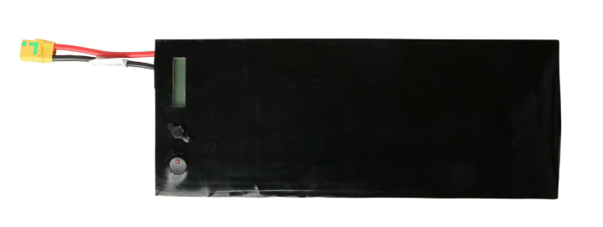

Figure 7 Diagram of Battery

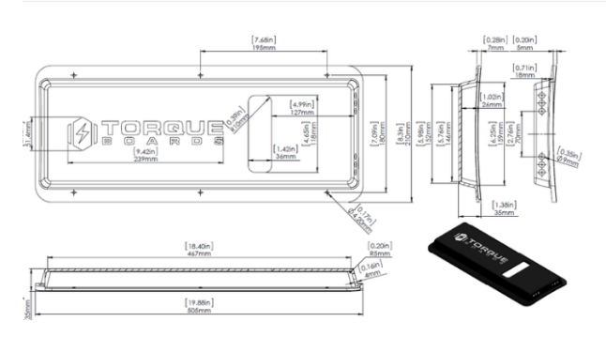

*Figure 8 Layout of Battery*

* 1. **Dual Motor Mechanical Kit**

We choose Dual Motor Mechanical Kit for our product. The specifications of it are as follows:

* Torque Boards Exclusive Bolt on Motor Mount (Black)
* Choose between 50mm or 63mm Spacing.
* 50 Degree Torque Boards v2 Trucks (Black)
* Torque Boards Exclusive 36T Drive Wheel Pulley + (6 each) M6x50 Bolts (HTD5 12mm width)
* 14T or 16T Motor Pulley (HTD5 12mm width)
* 265mm High Torque Timing Belt (HTD5 12mm width) *Inward Mount
* Cost: $299.99

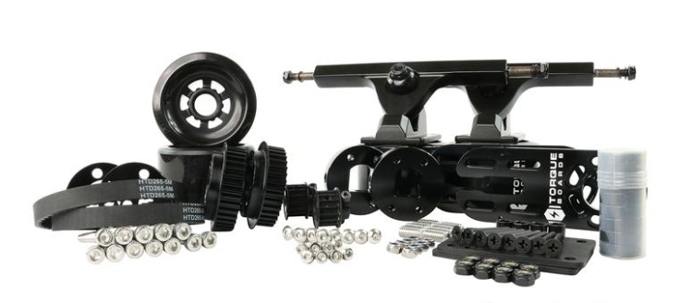

Figure 9 MOTOR MECHANICAL KIT (from Po-Chang Chiu)

The cost of MOTOR MECHANICAL KIT: $831

1. **Software design**

The functions are performed by the state chart shows below.

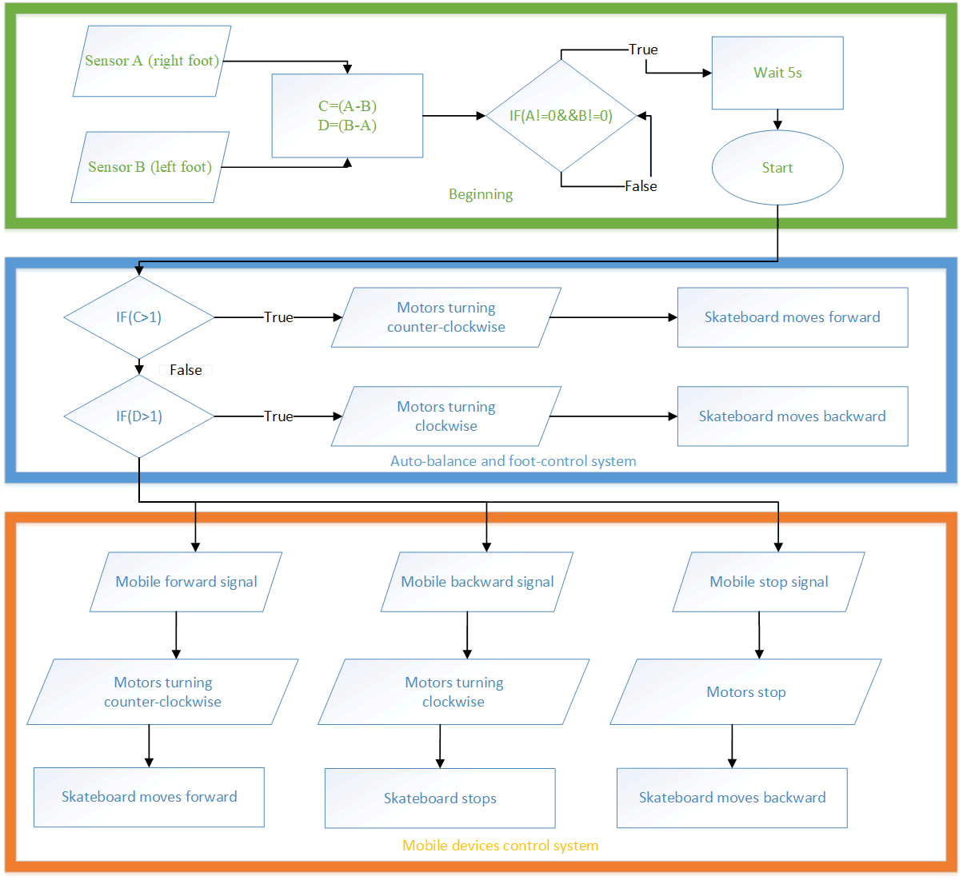

Figure 10 State chart

* 1. **Beginning**

First, when the user begins to stand on the skateboard, the weight sensor detects if there is an object on the skateboard. Then the sensor will give the user five seconds to move the foot to the correct position. Finally, the balance and foot control system will start working.

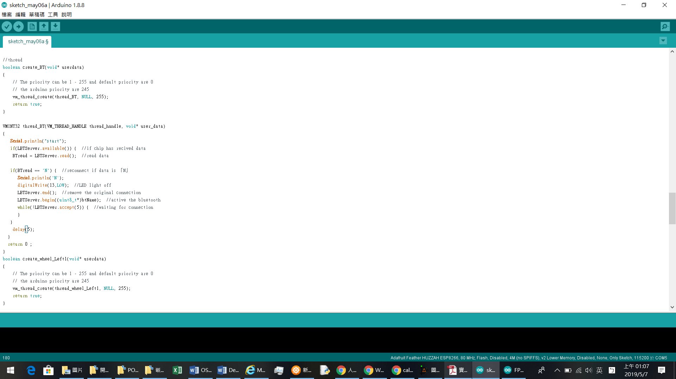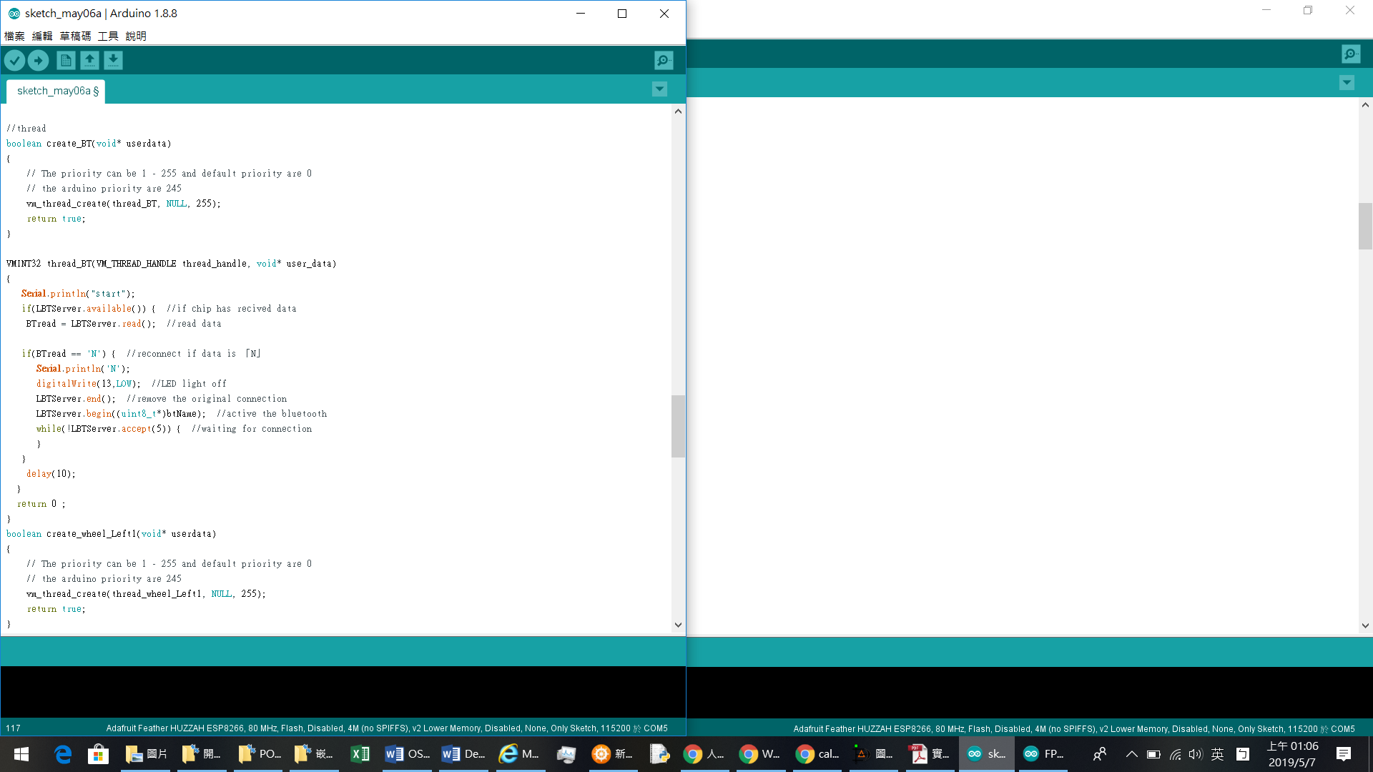

* 1. **Auto Balance and Foot control system**

Our electric skateboards can be controlled with mobile devices. The mobile device is connected to the skateboard via Bluetooth. After the user stands on the skateboard, the skateboard sensor will begin to detect the user's weight. If the connection is lost or the mobile device is powered off, the user can still control the skateboard with the foot. The sensor detects the user's weight and gives five seconds to put the foot in the correct position. The algorithm we designed is that if the load cell (A) minus the load cell (B) exceeds 15 kg, which means that the user's center of gravity is on the right foot and wants to move forward, the then slide will start moving forward. On the other hand, if (B) is greater than (A) by more than 15 kg, the user's center of gravity is on the left foot and the skateboard begins to move backward. In this way, the user can also control the skateboard through the limbs. In addition, our algorithm has a balanced control system compared to the ordinary skateboards in the market. This design is mainly for new users. Because new users may have difficulty balancing when they first use skateboards. Using the load detector to detect the user's weight, when load cell A or B detects that the weight is too concentrated on one leg, which means the user is about to fall, then the skateboard will move back and forth to help the user maintain balance. For example, if the user loses balance by applying excessive pressure on the forefoot, the skateboard will move forward to enable user’s rear foot to stand stably. This balance system is good.

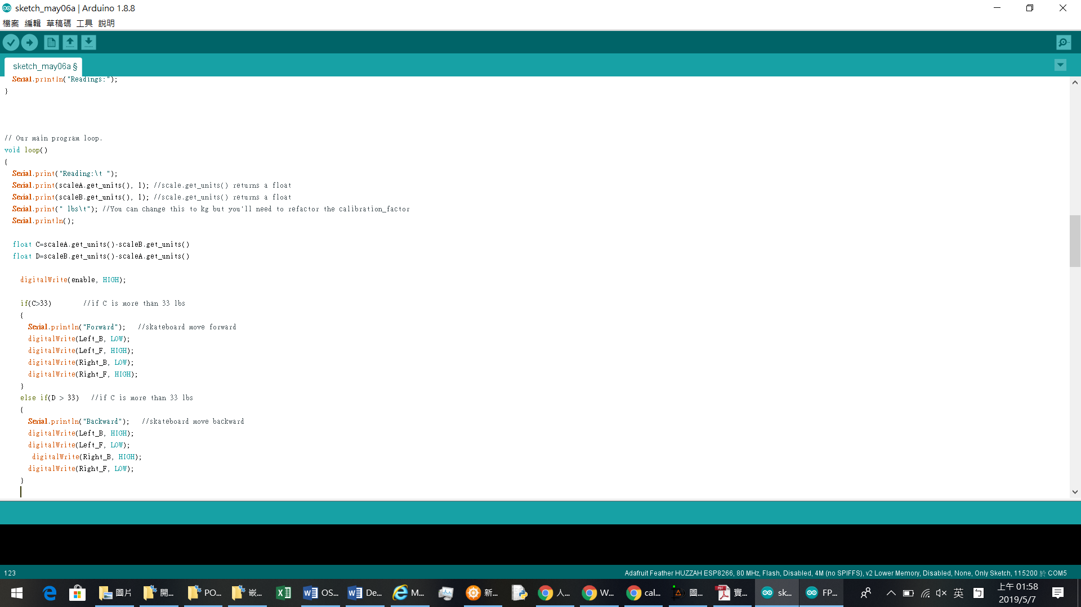

* 1. **Mobile Phone Control System**

Users can control the skateboard forward, backward and stop through our Android app. The application can display the connection status between the skateboard and the device and send a notification to the user when the two are disconnected.

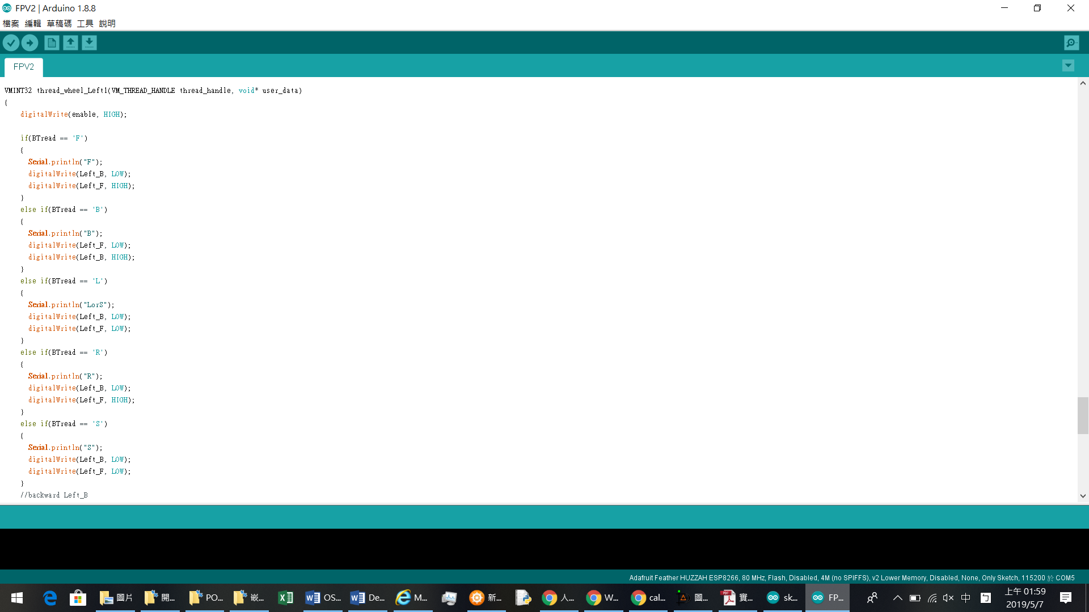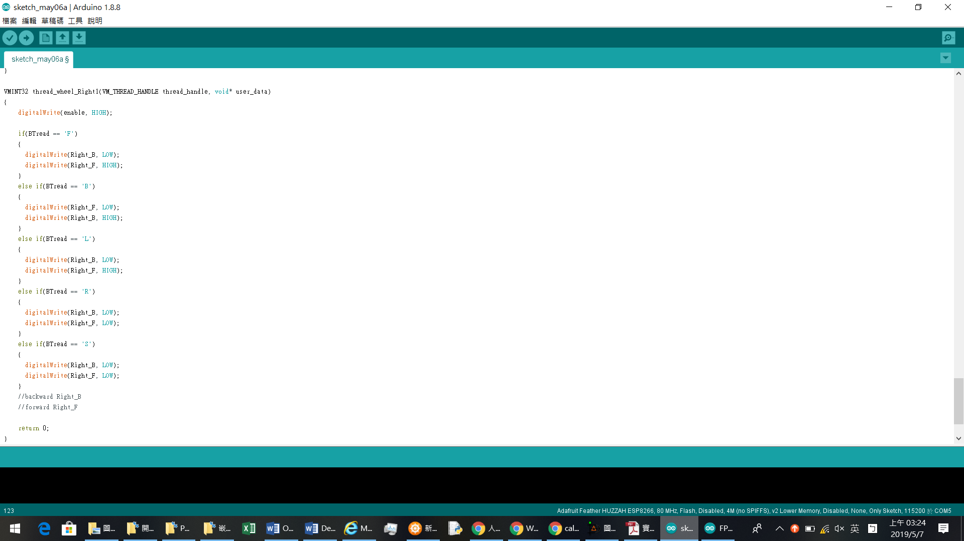

* 1. **Android Application**

We use MIT App Inventor create an app to control the electric skateboard

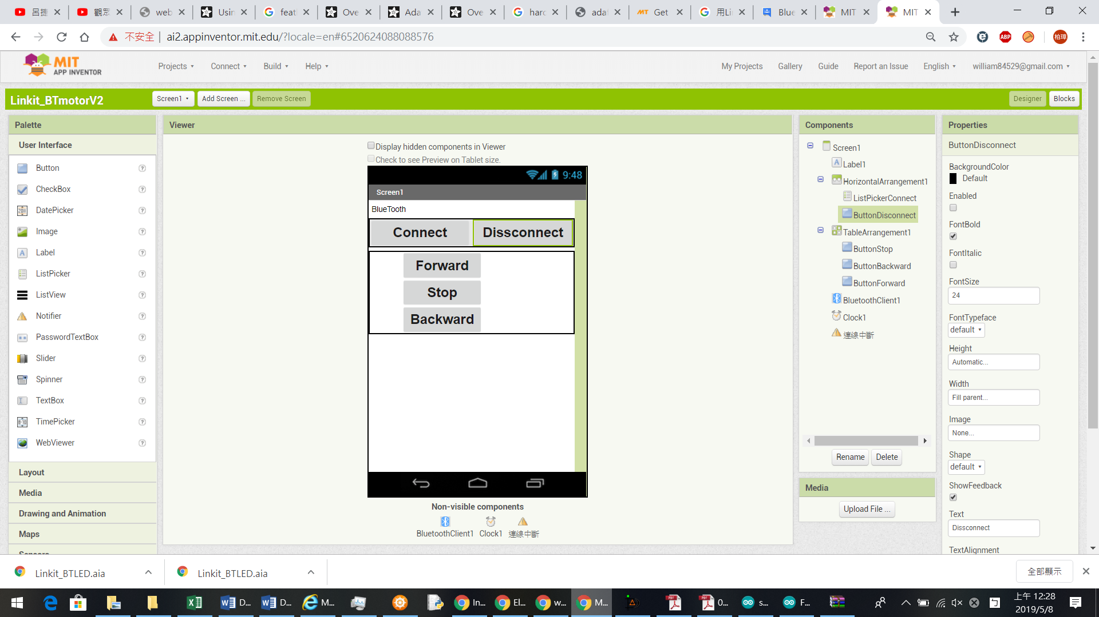

*Figure 11 The interface of MIT App Inventor*

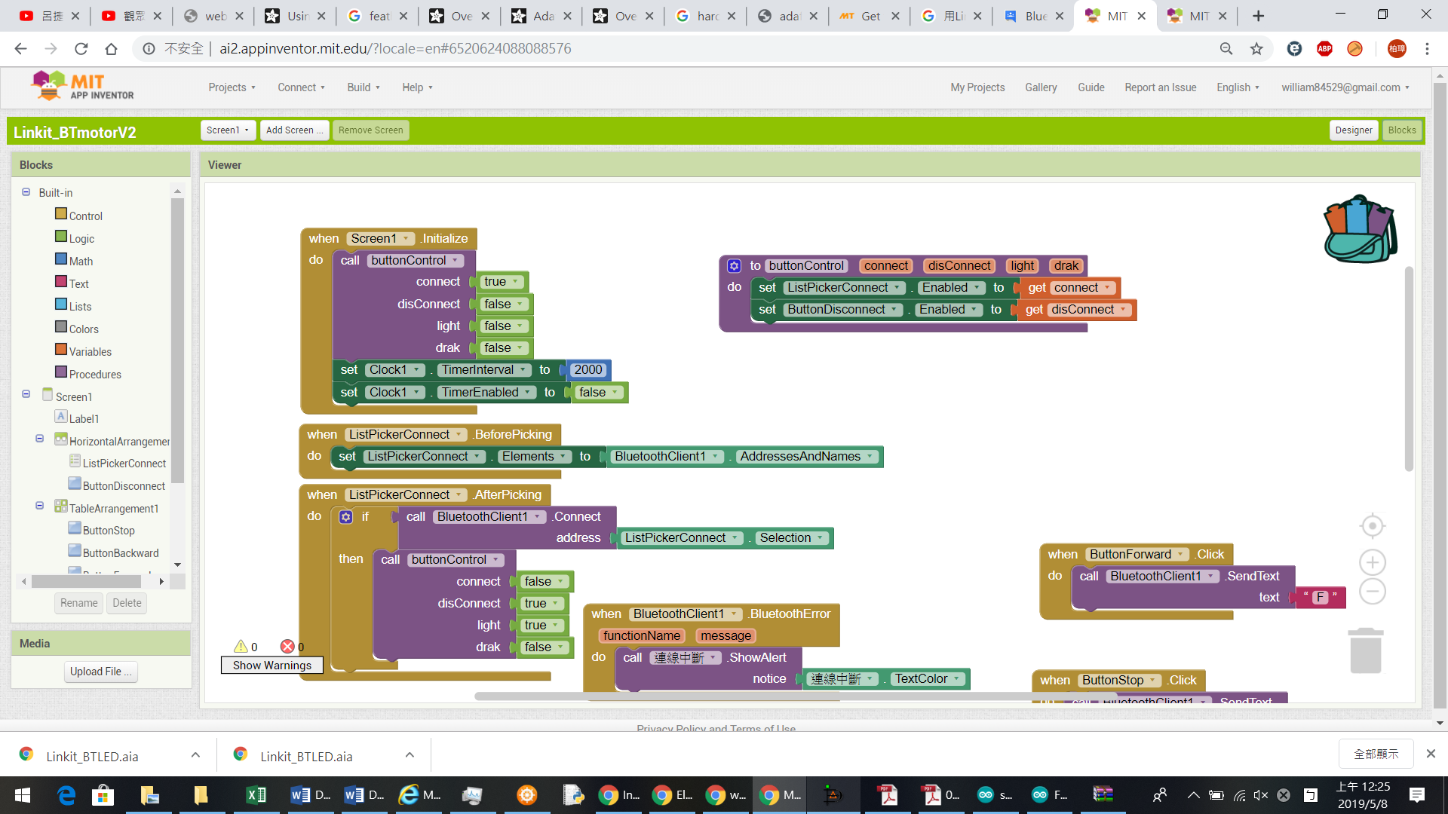

Figure 12 The code for the app

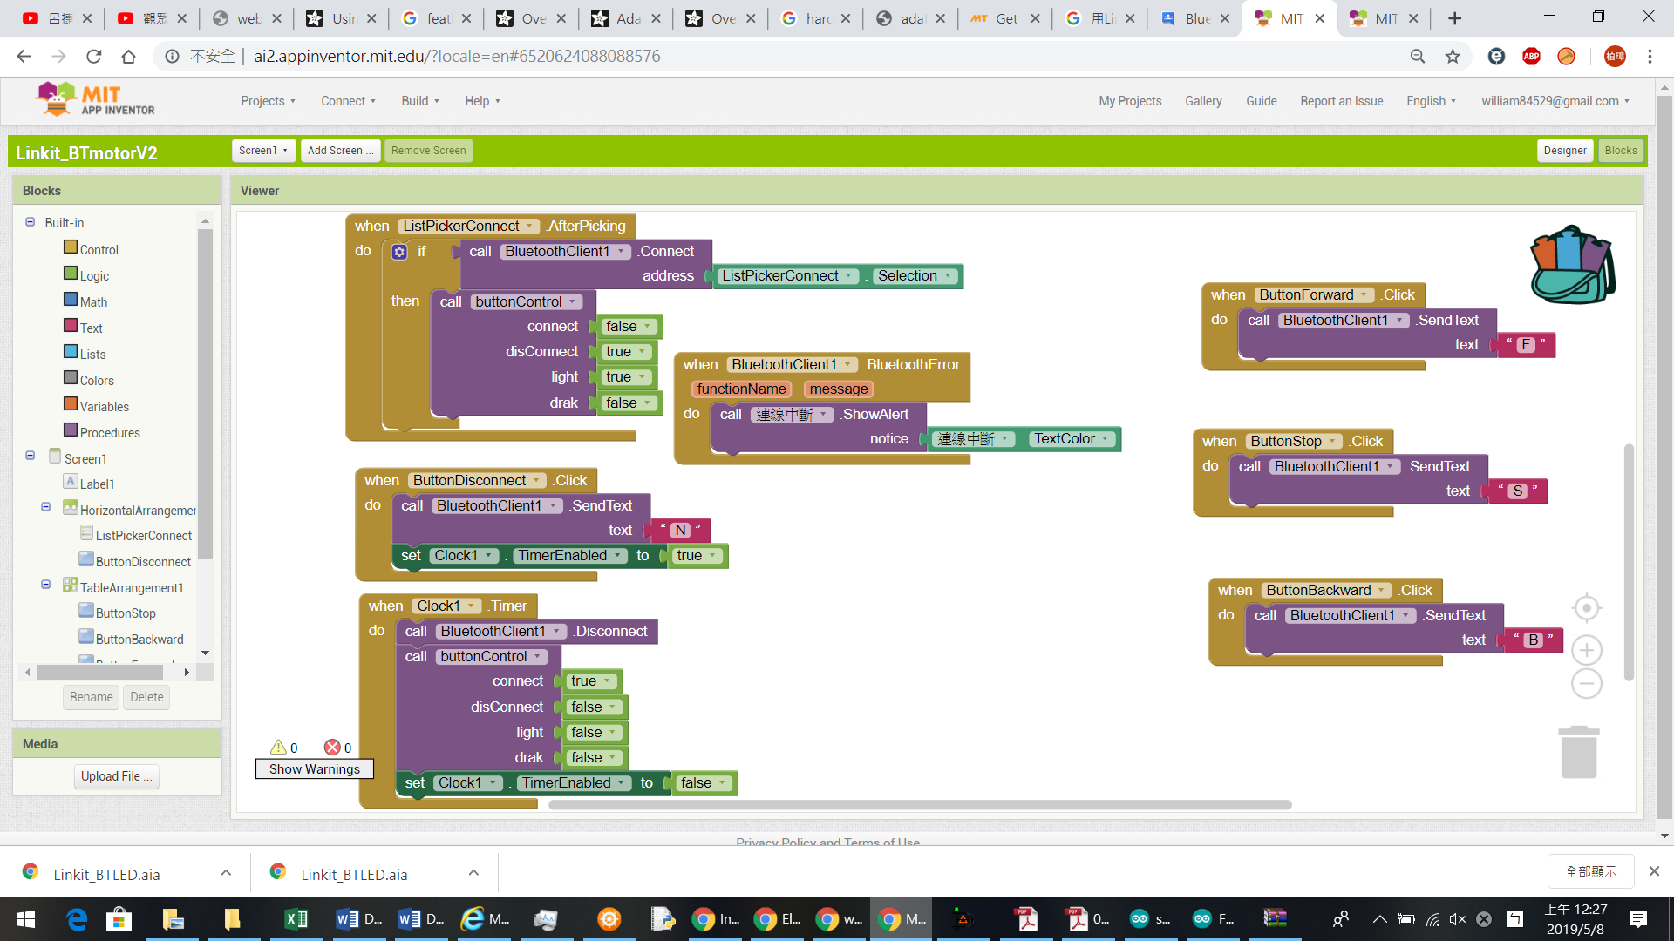

Figure 13 The code for the app

1. **Evaluation**
   1. **The evaluation for the load cell sensor**

First of all, I consider the situation where the user is too heavy. The measurement results in the figure below show the difference in the value of the scaleA.get_units() of Arduino due to the applied pressure. I use +5V to sensor and Arduino. The sensor is obviously not linear, but this is normal.

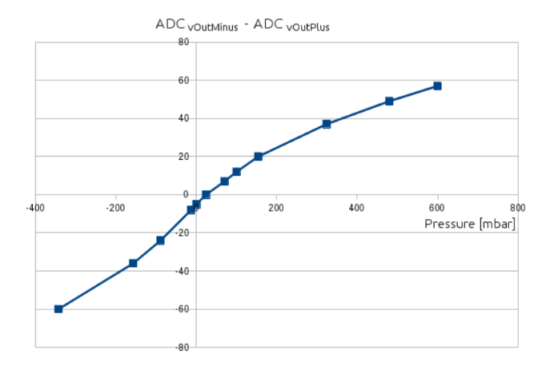

*Figure 14 Tests with a pressure*

I did some pressure values from 900 mbar to 2000 mbar. The SPX3058D has a pressure range of -500 mbar to +500 mbar. The sensor's offset and curve vary slightly, so the sensor is still available. So our algorithm is based on the difference between the two sensors. If the user is too heavy, it doesn't matter, as long as the two sensors use the same curve. The processor can still calculate the difference

* 1. **Processor Evaluation**

The list below shows that if the user need, there are always more option that can be take

|  |  |  |  |  |
| --- | --- | --- | --- | --- |
| Processor name | Arduino Nano | Linkit One | Edison | Raspberry PI |
| Power consumption | USB 5V 114mA Idle | 3.7~4.2V Li-battery  0.3~3mA DC Current per I/O | Input 3.3V~4.5V  Output 100mA at 3.3V and 100mA at 1.8V | USB 5V |
| Arduino compatible | 🗸 | 🗸 | 🗸 | 🗴 |
| Performance of processor | Medium | Medium | Zero | High |
| OS | Arduino IDE | Arduino IDE  Linkit OS | Yocto Linux V1.6 (MPU)  RTOS (MCU)  Arduino IDE | Debian GNU/Linux  Fedora  Arch Linux  RISC OS |
| Price ($) | 22 | 79 | 50 | 35 |

Table 1 Processor comparison (from Miaoyu Niu)

* 1. **Battery Evaluation**

|  |  |  |
| --- | --- | --- |
| Battery power pack | 12s2P | 12s4P |
| Battery life | 10-14 mile | 25-30 mile |
| Working temperature | -25~65 ℃ |  |
| Warranty | 1 year | 1 year |
| Weight | Approx:1.7 KG | Approx:2.5 KG |
| Cost ($) | 330 | 450 |

Table 2 Battery comparison (from Miaoyu Niu)

Consider the ways in which the product performance might vary in different operating conditions. The user can choose the processor and battery to get the performance that they need.

1. **Conclusions**

Skateboarding is a very popular sport, and electric skateboards can provide convenience for users. For example, students can choose electric skateboards to take classes between buildings. Our products incorporate advanced technology into skateboarding to familiarize people with the benefits of somatosensory pressure control and balance control during skateboard use. At the same time, the use of skateboards for beginners has become easier due to the addition of intelligent pressure sensing and balance control methods. Compared to the popular walking tools on the market, our skateboards have the advantages of light weight, reasonable price and convenient carrying.

Finally, since our products were created by our team, the code and numbers we use in the article are the same.

**Reference**

*12S4P Electric Skateboard Battery EPOWER Pack (Samsung 30Q)*. [online] DIY Electric Skateboard. Available at: https://diyelectricskateboard.com/products/electric-skateboard-battery-epower-pack-12s4p [Accessed 8 May 2019].

Anon, (2019). [online] Available at: https://learn.sparkfun.com/tutorials/load-cell-amplifier-hx711-breakout-hookup-guide/all [Accessed 8 May 2019].

Instructables.com. (2019). [online] Available at: https://www.instructables.com/id/How-to-Interface-HX711-Balance-Module-With-Load-Ce/ [Accessed 8 May 2019].

Learn.adafruit.com. (2019). *Using Arduino IDE | Adafruit Feather HUZZAH ESP8266 | Adafruit Learning System*. [online] Available at: https://learn.adafruit.com/adafruit-feather-huzzah-esp8266/using-arduino-ide [Accessed 8 May 2019].

Store.arduino.cc. (2019). *Arduino Nano*. [online] Available at: https://store.arduino.cc/usa/arduino-nano [Accessed 8 May 2019].